Please apply the following edits globally across the site, not just to the examples or pages referenced in the screenshots:
Text:
- Body text needs to be in black (HEX #1A1A1A), not navy
- Page Headers need to be in Times New Roman/Leitura Roman 1 (not bolded) and in Navy (HEX #003769)
- Section headings for the widget boxes should be in Arial/Fakt, navy, and bolded
- The box headings (application approved, program names, college names) should be Arial/Fakt, teal, and bolded
- Here is something I mocked up for the Overview page, if we can change to this type of formatting for the site (I will also share the power point slide so you can see the colors):
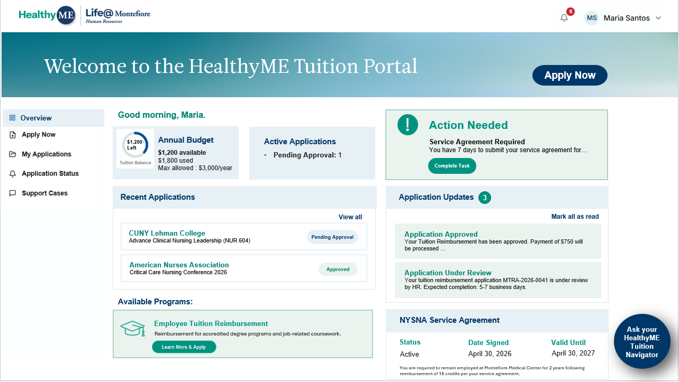
- Do not use all caps text for headers or body text
- Do not bold body text. Example:
 | 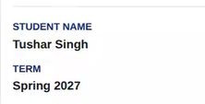

Buttons: All buttons need to be the rounded pill shape, not a rectangle with rounded corners:
 | 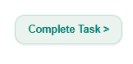
 | 

  - Buttons should not have an outline, but be a solid color
 | 

- Highlighted areas should be a square rectangle, no rounded corners
 | 

- Alert notification circles should not be in black. Please use the teal from the guide:
Reference: | 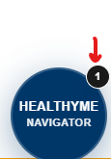

- All caps should not be used in box headers: 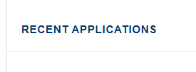
- Font colors across the site need to match what is in the branding guidelines.
- Graphics should not be in circles. They should be a contrasting color from the background, for example in the case below they should be teal on the light green background:
 | 

Links: Need to be bolded and not underlined. Links can be in navy or teal, depending on what the header color is for that section.

Widget and Callout Boxes:
- No rounded corners on boxes
- Headers should be in Arial/Fakt and bolded (see Text section at top of page for more details)
- Additional colors for boxes can include, in addition to white:
- A lighter wash of the mint: HEX #ebf3ef
- Light blue: HEX #E6F0F5
- Teal: HEX #009480
- White should have the light grey border for the whole section (border thickness 1-2), and if boxes within the widget are white and need a border, please use the mint (HEX #acd3c0) or light blue (HEX #E6F0F5) colors

Graphics:
- No colored graphics (see page 15 of our branding guidelines for examples)
Language:
- Use employees not associates
- Please replace all cases of “Montefiore Health System” with “Montefiore Medical Center”
The following are additional edits that apply to certain pages:
Login page
- The logo is only needed once on this page. Please remove the reverse white logo
- Change all “Montefiore Health System” to “Montefiore Medical Center”
- Change language under Sign In from “HealthyME Navigator” to “HealthyME Tuition Portal”
- Remove the sentence: “NYSNA Article 35 compliant.”
- Change “Tuition Reimbursement Agent Platform” to “HealthyME Tuition Portal”

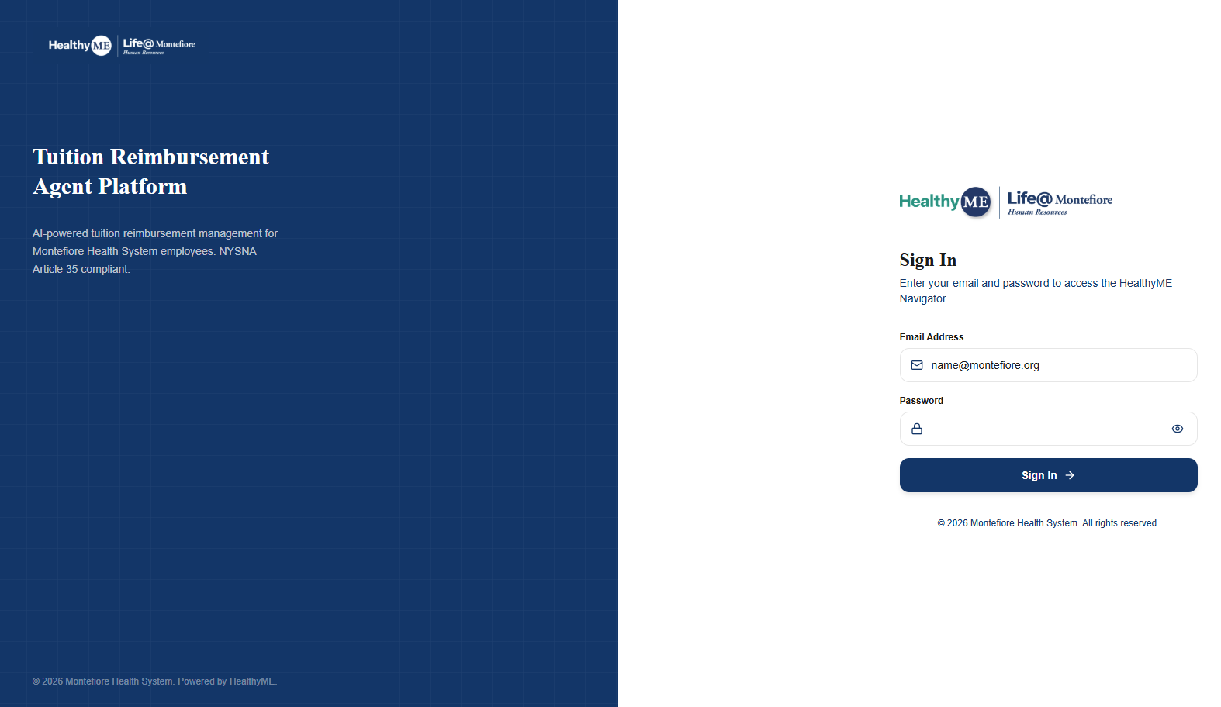

Overview page
- HealthyME Navigator shouldn’t be in all caps. Please set with Arial/Fakt Bold as: HealthyME Navigator
- Circle should have a drop shadow to the bottom right in grey, not blue
- This circle should not cover up the other text, please leave a white margin on the right (see overview mockup that I shared above)
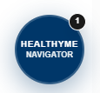
- Please confirm that you used the Gradient Mesh file I sent to create the header. Per HealthyME brand guidelines on page 14, only use the approved file of the gradient mesh, do not modify it or create new gradients.
- The boxes shouldn’t be spread across the page like this. I know we asked not to scroll as much, but there is a lot of unused white space here. See below for what I’m referring to: 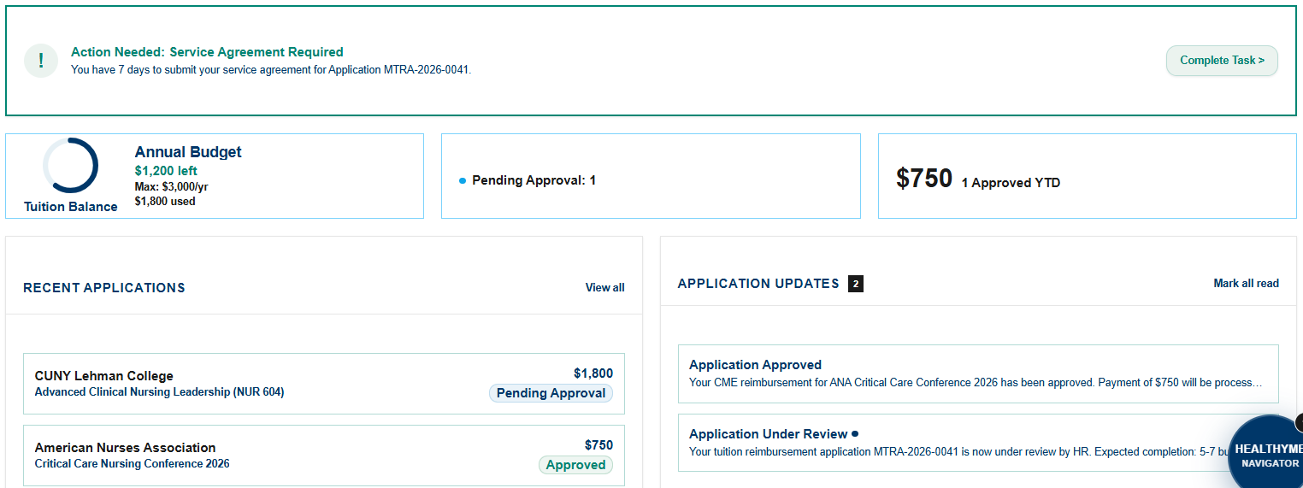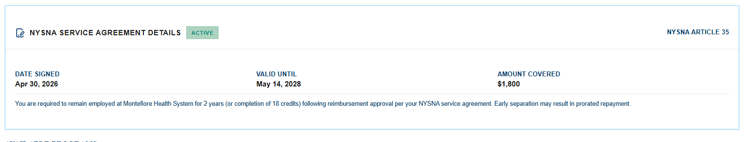

- Also, do we need to have the box with $750 (Total Reimbursed) if we are including the $ amount used in the Annual Budget box? I think we should remove the Total Reimbursed box and have this info in the Annual Budget box.
- You can have the Action Needed box on the top right of the page in a more compact way, but make the background the light mint specified above with the regular mint color as the border
- The boxes for Annual Budget, Active Applications (missing header from the most recent screenshot above), and Total Reimbursed (also missing header from above) should be to the left of the Action Needed box at the top.
- In Application Updates, it should have “Mark all as read” not “Mark all read”
- For the service agreement box, I’m not sure why “NYSNA Article 35” is in the right corner. It doesn’t link to anything and it should be removed.
- Please see language changes I made for this box in the mockup I provided
- This is about credits covered, not amount, but I removed this as it is mentioned in the smaller text for this box that I updated

Apply Now page
- The steps and continue button are too far down. These should be moved under the programs options and centered.
- Will the correct info be included about these programs? For example, the scholarship is $500, not up to $10,000, with no credit requirement.
- We can’t say “reimbursement program” at the top since they’re not all reimbursement programs (the scholarship program for example)
- The graphics need to follow the style specified in the HealthyME brand guide on page 15, they should not be colored at all. Please make this change site-wide
- Body text should not be navy
- 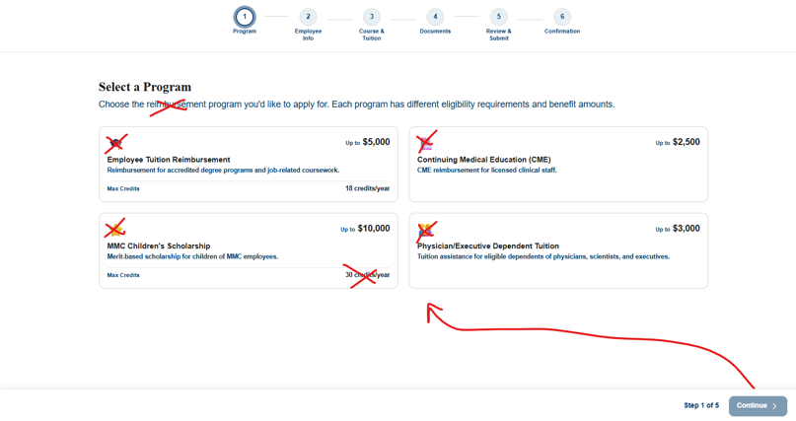
- Please adjust headers and box shapes to reflect global guideslines from above. Employee Info should not be bolded and should be navy, subhead should be bold and teal (“verify your details…”), Personal Information should not be all caps and should be Arial bolded. Please make these changes to the other pages in this flow too. Here is a screenshot for reference: 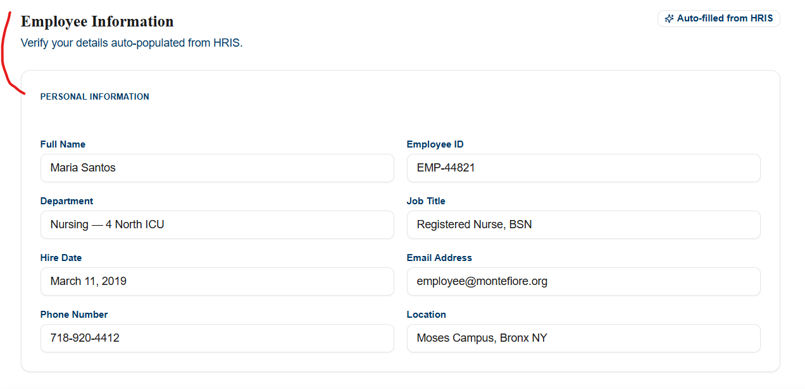

- Add Another Course is a button and needs to reflect the global guidelines above. I’m also not sure what SOP Checklist Warning Means. I think this should be changed to “Important: Application contains in-progress or enrolled courses. Please note that final reimbursement depends on grade verification.”
- 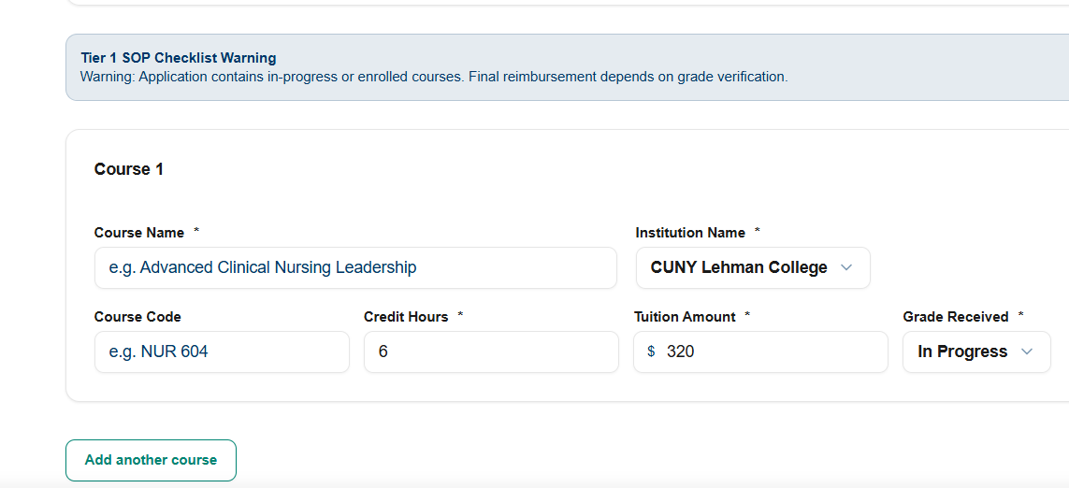
- I could not advance beyond Step 3 of this process, no matter what I did. If it’s not clear to me what to do, it won’t be to the nurses.

My Applications page
- Please follow the layout for this box of what I have mocked up for the overview page above. Also follow the above global changes for boxes, buttons, headers:

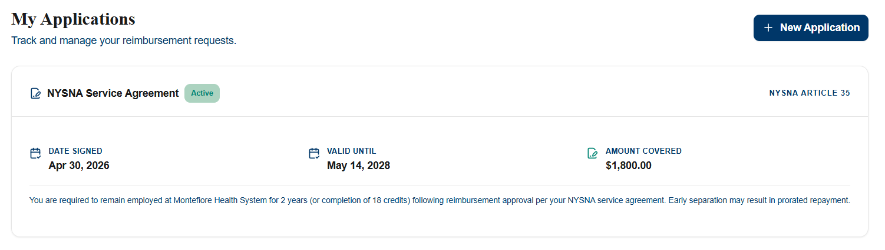

Application Status page
- Please follow guidance above regarding headers/text, graphics, boxes, buttons, colors:
- 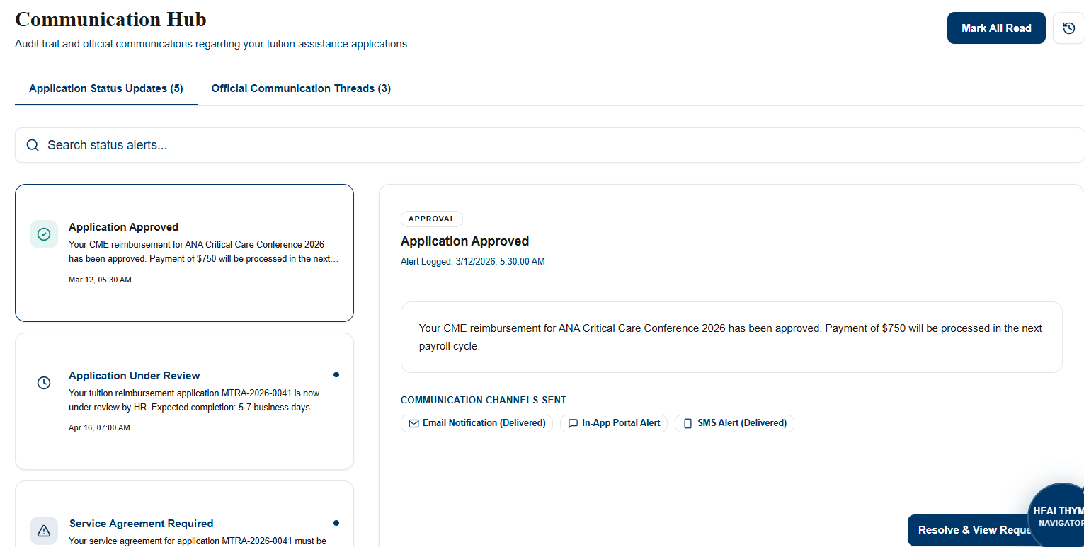

Support Cases page
- Section headers across all pages should be the same size. Internal Support Helpdesk appears smaller than the headings on the other pages.
- Please refer to my comments above regarding header text/color, buttons, etc.
- The Priority and Status columns shouldn’t have boxed/highlighted text. Please make the Action column “View” buttons follow the above guidelines as indicated above
- 